**Zakariya Anwar Khan**

**FA21-BSE-042**

**BSE-4A**

**Monitor Line ( Lineman )**

**Main Success Scenario:**

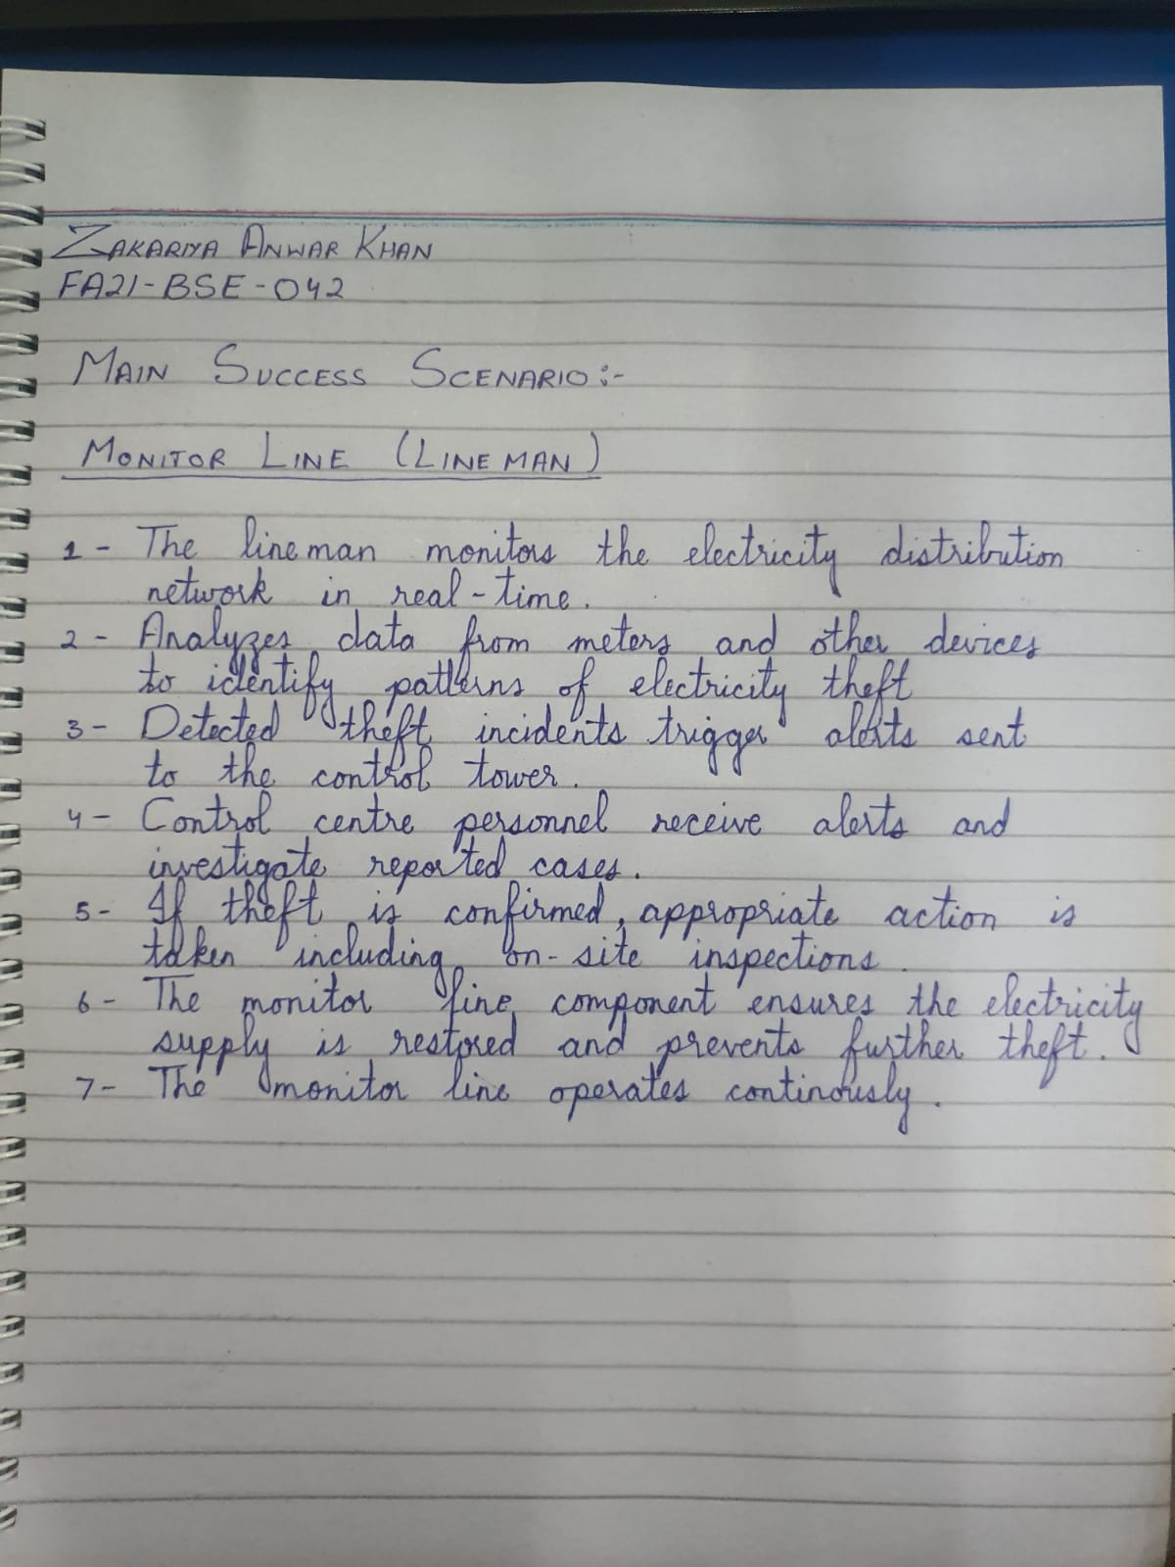

**System Sequence Diagram:**

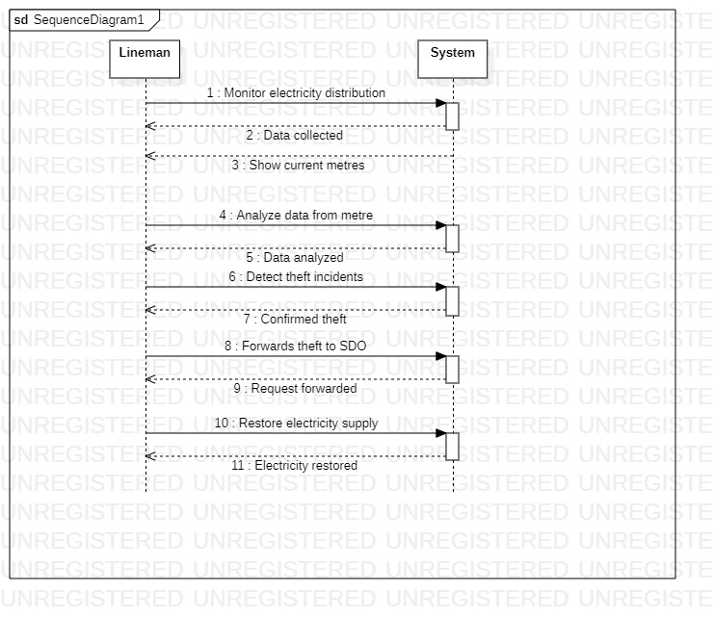

**GUI:**

